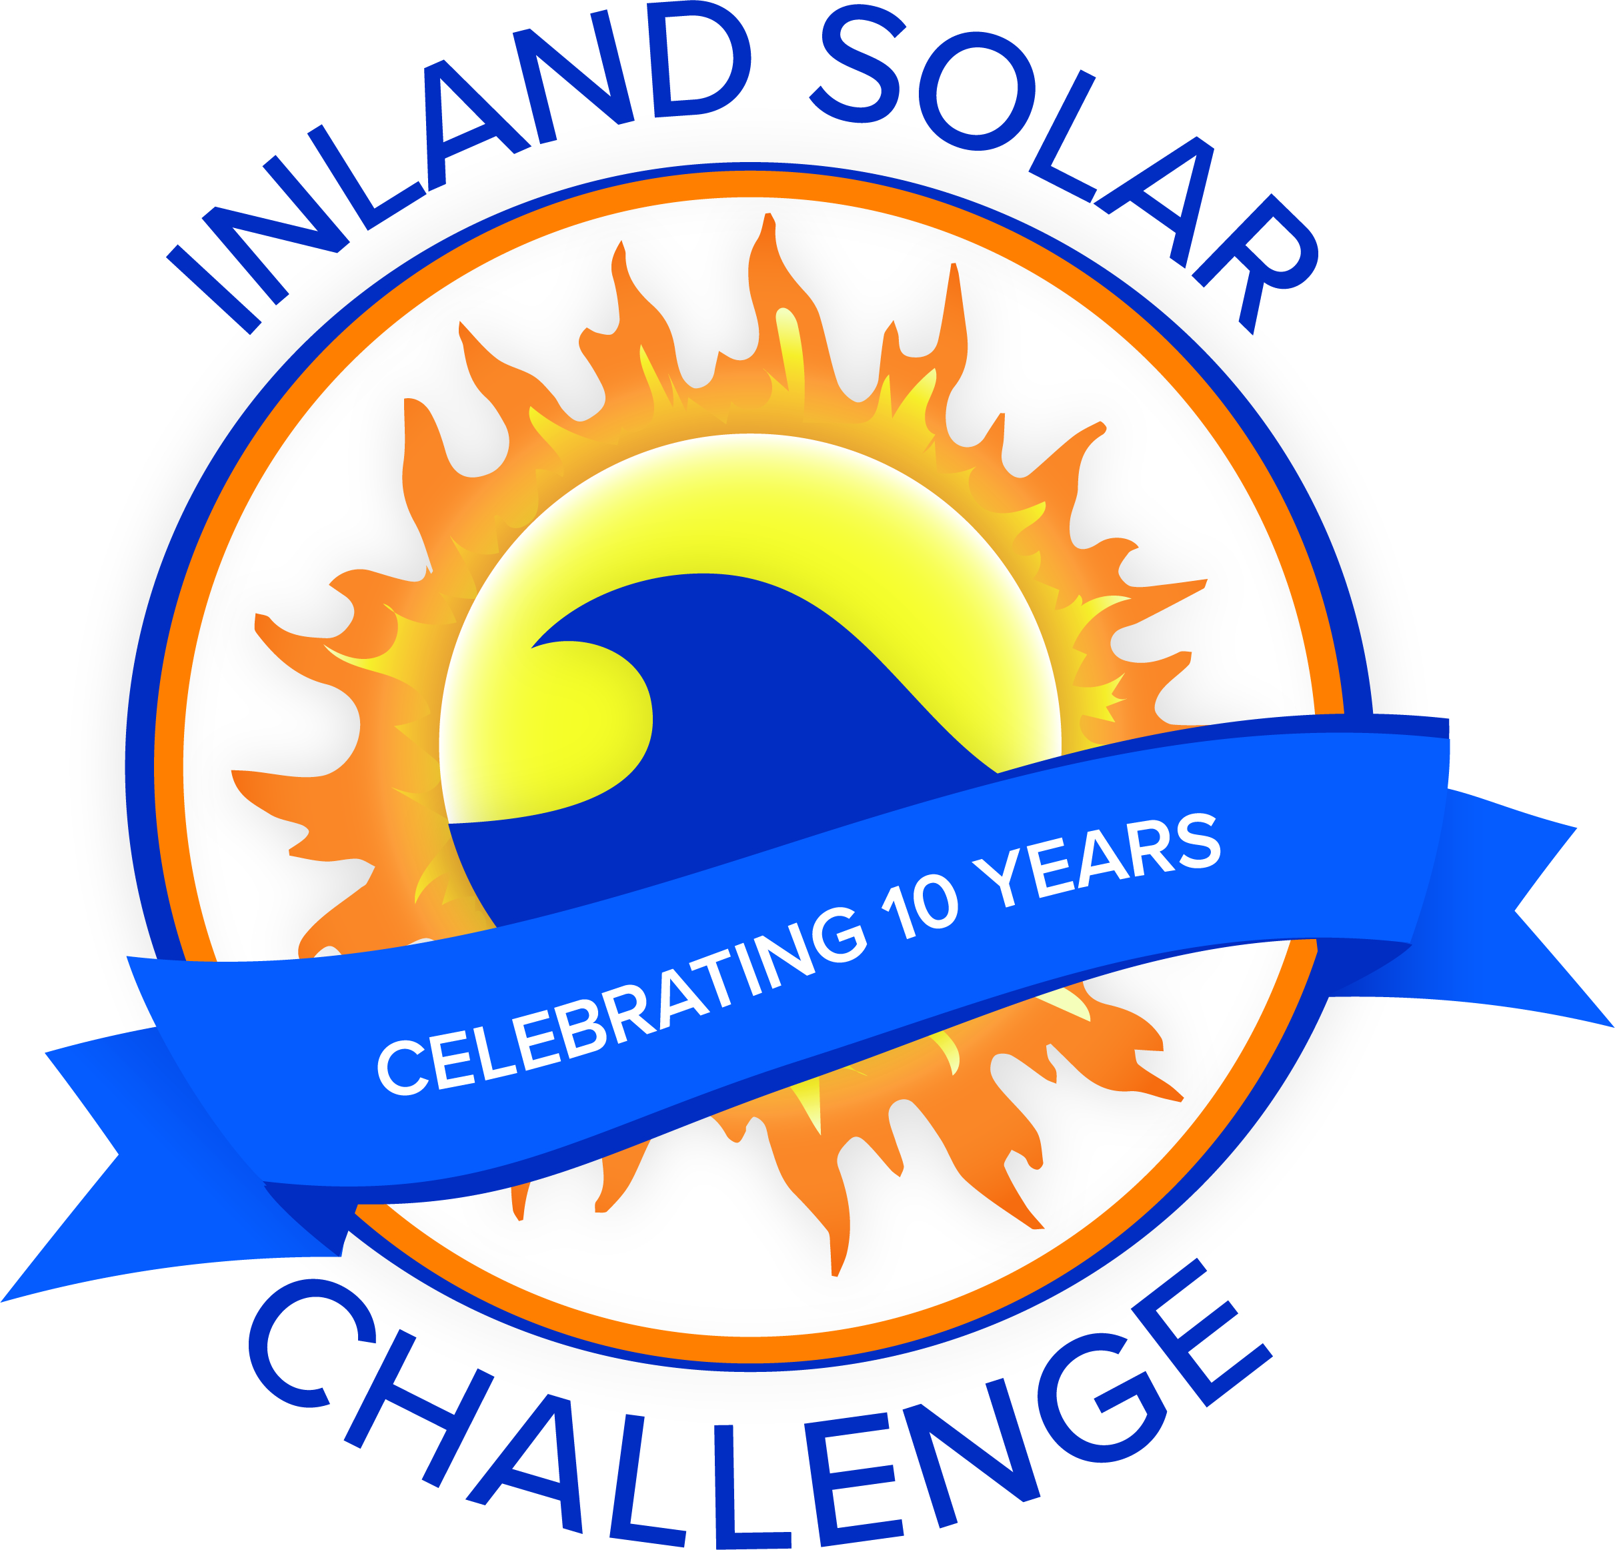
ISC Meeting Agenda
Meeting with ISC Committee
Date | time 11/17/2021 2:00 PM Location Zoom Meeting
https://sbmwd.zoom.us/j/89958649314
Meeting ID: 899 5864 9314
One tap mobile
+12532158782,,89958649314# US (Tacoma)

Agenda Items
- Welcome and Introductions
  - San Bernardino Municipal Water Department
  - Coachella Valley Water District
  - Yucaipa Valley Water District
  - East Valley Water District
  - West Valley Water District
  - City of Redlands

- Approval of 10/27/2021 Committee Minutes

- Task List / Schedule

- 501c3

- Boat Build
  - Participating Teams
  - Waivers – Added language
  - Items assignment

- Sponsorships

- Budget

- Additional Items/Discussion
  - Park Contract

- Teacher Update Meeting December 1st at 4:00PM

- Adjourn

