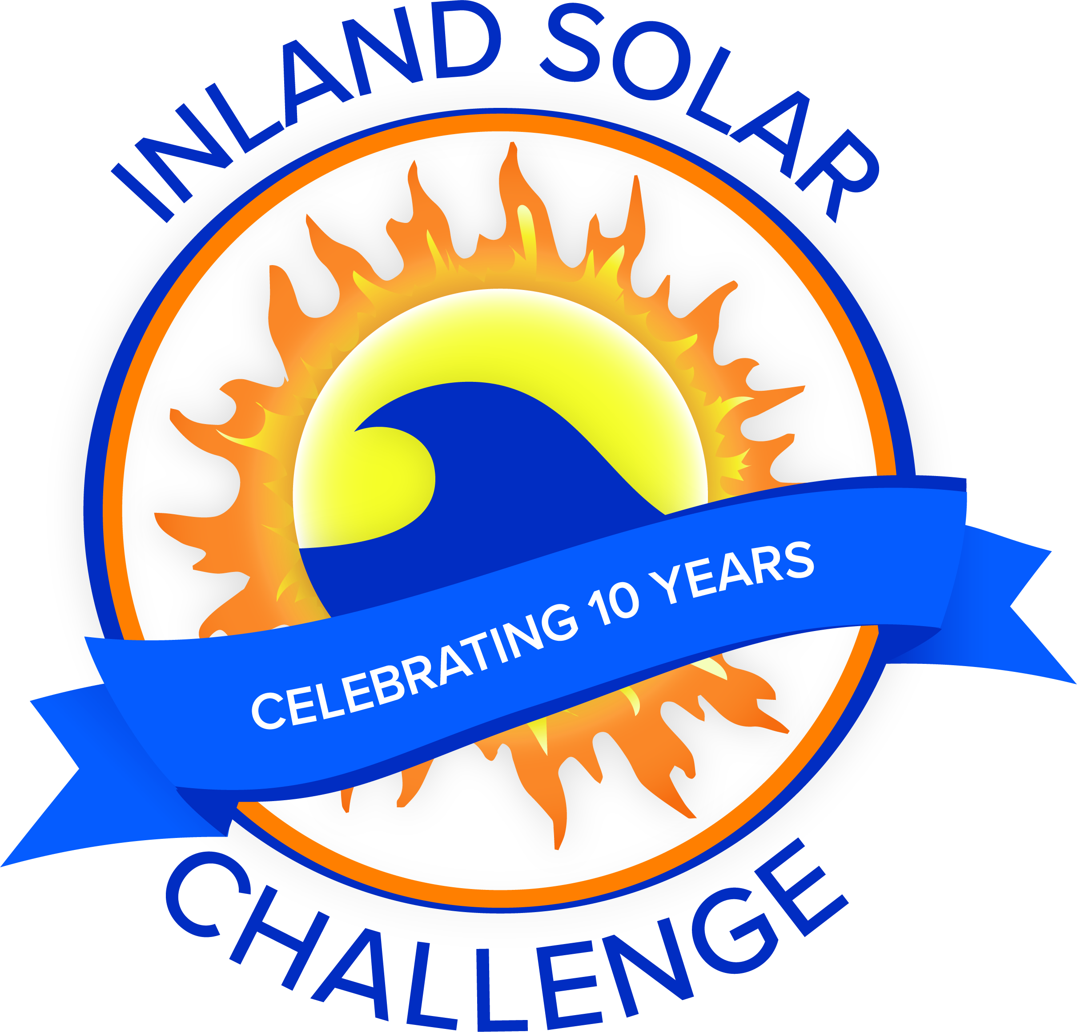
ISC Meeting Agenda
Meeting with ISC Committee
Date | time 4/20/2022 12:00 PM Location Yucaipa Regional Park
33900 Oak Glen Road, Yucaipa, CA 92399

Agenda Items
- Introductions
  - San Bernardino Municipal Water Department
  - Coachella Valley Water District
  - Yucaipa Valley Water District
  - East Valley Water District
  - West Valley Water District
  - City of Redlands
  - Valley District

- Committee Roles

- Event Scheduling
  - Volunteers needed?
  - Technical Inspectors (how many needed for Friday?)
  - Attendance
  - Kitchen/Meals
  - Friday Qualifying Time? Team order?

- Update from Technical Workshop
  - Rules:
    - Liability Waiver Updates – Due April 29th

- 501c3 Status/Renewal
  - Bank Account

- Sponsorships
  - Boat stickers – Artwork for Pass Agency

- Budget

- Supplies

- Check List

- Task Review / Discussion

- Judges / Scoring
  - Technical Reports
  - PSAs
  - PSA judges at event (Pass Agency: Ron Duncan, Kevin Walton Valley District: June Hayes, Susan Longville)

- Additional Items/Discussion
  - Power/Water at park

- Next Meeting
  - Final Teacher call – First week of May?
  - Virtual Wednesday, May 11 or Thursday, May 12?
- Adjourn

