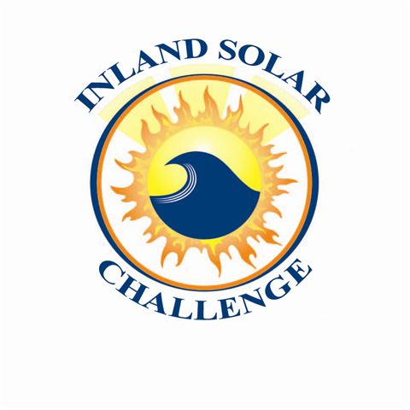
ISC Meeting Agenda
Meeting with ISC Teachers
Date | time 2/17/2022 4:00 PM| Location Zoom Meeting
https://sbmwd.zoom.us/j/85730777378
Meeting ID: 857 3077 7378

Agenda Item

- Welcome and Introductions

- 2022 Event Discussion
  - Event weekend is May 20-22, 2022
  - School status on off-campus event/activities
  - Boat progress/Boat kits
  - Sponsorships
  - Event accommodations
  - Timeline

- Conservation Report Topic - Recharging Communities with Groundwater
  - Water Resource Presentations
  - Outline and Video due dates

- Additional Items/ Discussion
  - Rules
  - Technical Workshop, February 23, 2022 4:00-5:00 PM

