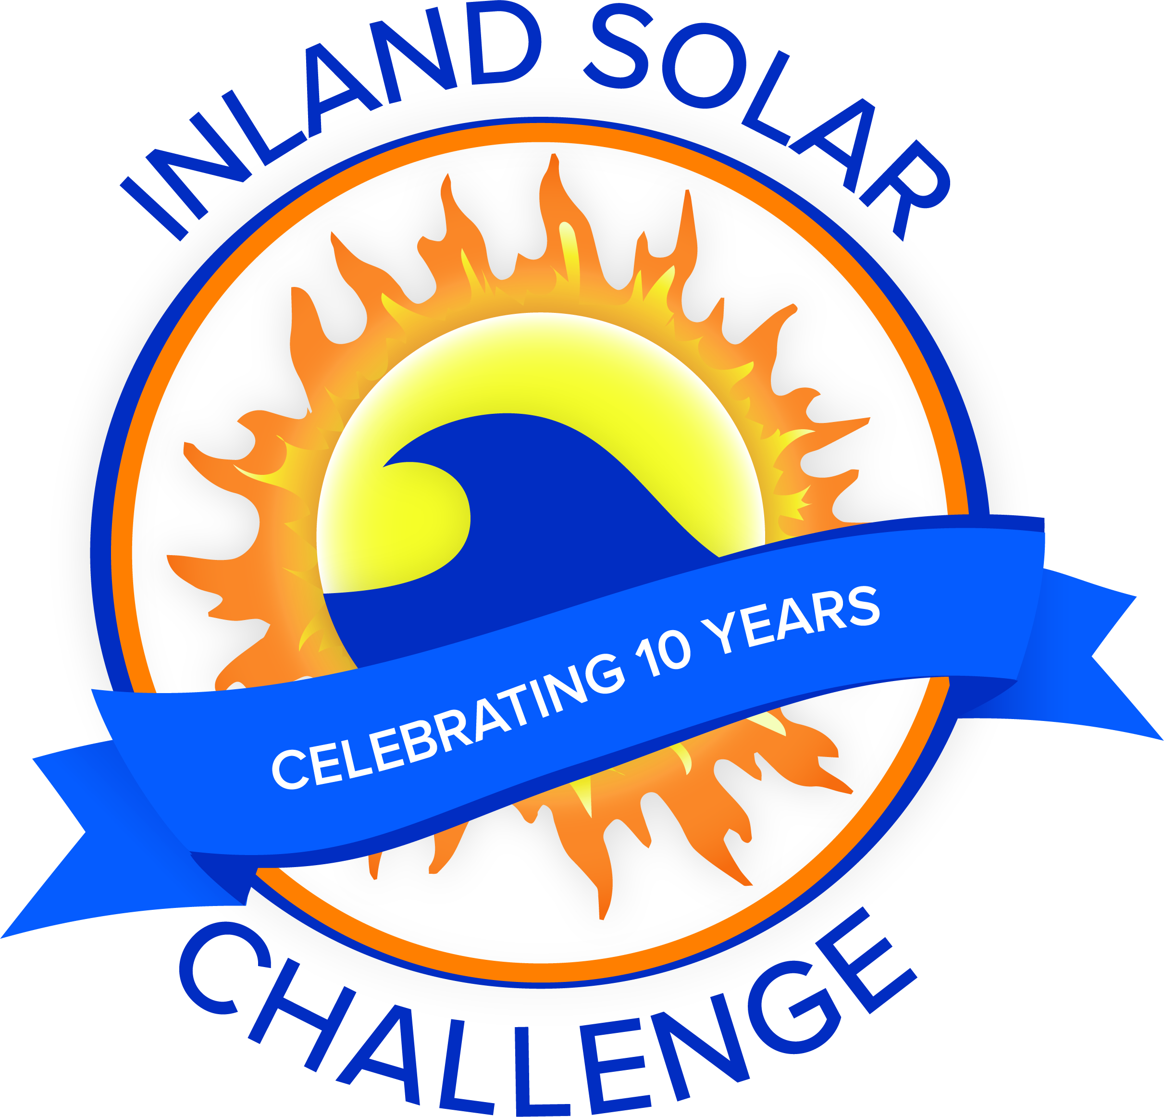
ISC Meeting Agenda
Meeting with ISC Committee
Date | time 2/23/2022 3:30 PM Location Zoom Meeting
https://sbmwd.zoom.us/j/89039541467 | Meeting ID: 890 3954 1467

Agenda Items
- Welcome and Introductions
  - San Bernardino Municipal Water Department
  - Coachella Valley Water District
  - Yucaipa Valley Water District
  - East Valley Water District
  - West Valley Water District
  - City of Redlands

- Park Contract

- Committee Roles
  - Vacancy for Secretary

- 501c3

- Sponsorships
  - Retail Business Sponsorships
  - Presentation to SG Pass Water Rescheduled for 3/14/22

- Budget
  - Park Contract – Quoted $7,087

- Additional Items/Discussion

- Technical Workshop Today 4:00PM

- Next Meeting

- Adjourn

